**Capt. Lauren Kolod, No. 9, Spirit Number 688**

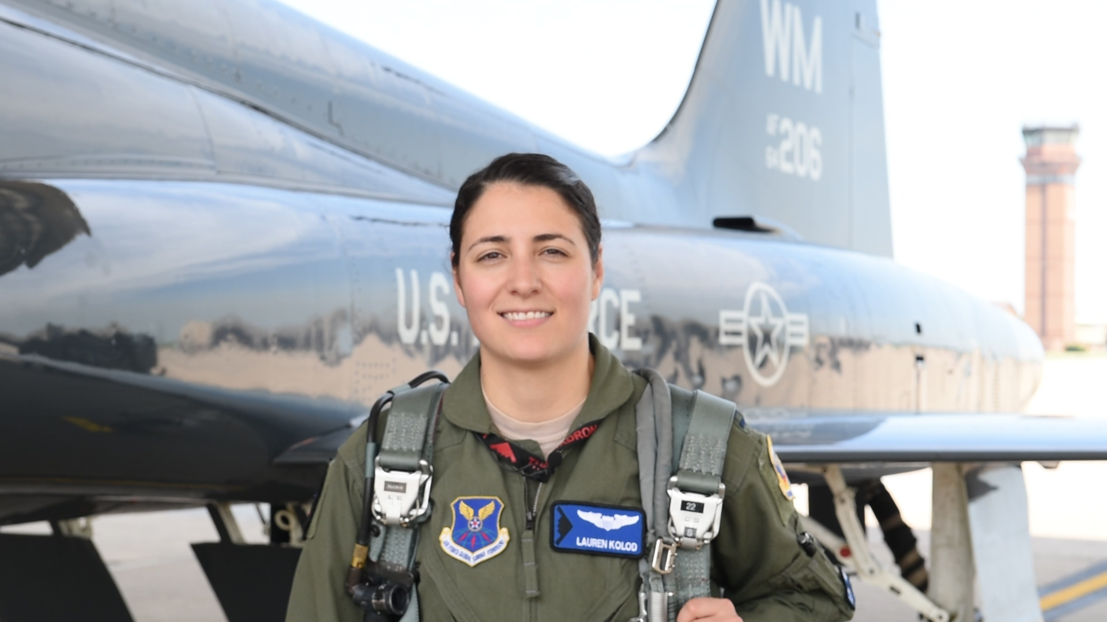

**By Brye Steeves**

**509th Bomb Wing Public Affairs**

It had never occurred to Lauren Kolod that she could be a pilot – even after she joined the U.S. Air Force.

It was her first year at the U.S. Air Force Academy, where a recruitment brochure filled with pictures of cadets doing cool-looking things had beckoned Kolod from the Pittsburgh area. Kolod’s new roommate introduced herself and told Kolod she was there to be a fighter pilot someday.

“I thought ‘oh wow,’ ” Kolod remembers. “I had never seen a female pilot – ever. There was Amelia Earhart, but I don’t remember every having seen another female pilot.”

What Kolod did see was an opportunity. And she took it. A few years later, in 2018, Kolod became the ninth woman to fly the B-2.

A lieutenant colonel at the Academy mentored Kolod and helped her get started on a path to becoming an aviator. He was also a B-2 pilot.

“All pilots love to talk about flying,” Kolod says. “And he loved talking about the B-2.”

After graduating from the Academy and pilot training, Kolod flew KC-135s, but let her commanders know from the start that she wanted to go fly the B-2 stealth bomber.

Never wavering from the goal, she found herself driving onto Whiteman Air Force Base in rural central Missouri on a dark rainy night. She would soon find out there was only one other female B-2 pilot there. “I thought, ‘What have I done?’” Kolod says with a laugh. “ ‘I really hope I’ve made the right decision.’ ”

The next morning, she saw a B-2 taxi and take off.

“I got chills,” Kolod remembers. “I was so excited about my job and to be a pilot.”

It’s a sentiment she wants other young girls to have.

“You need to see someone who looks like you to know you can do it,” Kolod says. “I never had, but that’s changing. When I put that helmet on, I become just another pilot, which is the best thing in the world. I so appreciate these women for paving the way and making it just a little easier for me.”